Digiphant dictionary

Manual

1. 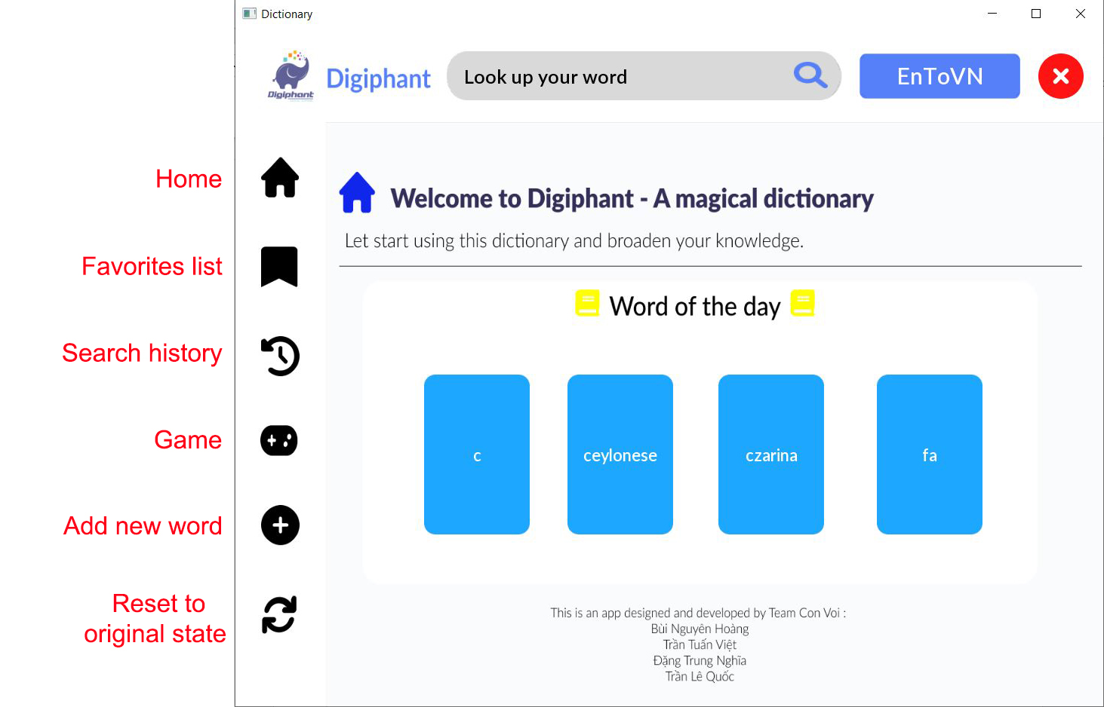Open app
2. Home screen

1. Favorites list

1. Search history

1. Game

* In game mod, the dictionary displays a keyword and 4 definitions, you can choose one of them.

1. Add new word

* You can add a new word with 3 definitions to current data set.

1. Reset to original state

* After a few changes, you can reset the dictionary to its original state.

Thank you for using our dictionary! ♥